KARNATAK LAW SOCIETY’S

GOGTE INSTITUTE OF TECHNOLOGY

UDYAMBAG, BELGAVI-590008

(An Autonomous Institution under Visvesvaraya Technological University Belagavi)

# (APPROVED BY AICTE, NEW DELHI)



Open Book Assignment 2 on

**“SMART PARKING SYSTEM USING IOT”**

*submitted in the partial fulfilment for the academic requirement of*

**6th Semester BE in**

**SENSORS AND SIGNAL CONDITIONING**

Submitted by

|  |  |
| --- | --- |
| **NAME OF THE CANDIDATE** | **USN** |
| Anvita Savadi | 2GI20EC025 |

**GUIDED BY**

**Prof. Praveen Kalkundri**

# 

# KARNATAK LAW SOCIETY’S

**GOGTE INSTITUTE OF TECHNOLOGY**

# UDYAMBAG, BELAGAVI – 590008

(An Autonomous Institution under Visvesvaraya Technological University, Belagavi)

**(APPROVED BY AICTE, NEW DELHI)**

# DEPARTMENT OF ELECTRONICS AND COMMUNICATION ENGINEERING



**CERTIFICATE**

This is to certify that Anvita Savadi of **6th Semester** bearing **USN:2GI20EC025,** has satisfactorily completed the course in *Open Book Assignment 2 on Sensors and Signal Conditioning*. It can be considered as a bonafide work carried out for partial fulfilment of the academic requirement of 6th Semester B.E. prescribed by KLS Gogte Institute of Technology, Belagavi during the academic year 2022-23.

The report has been approved as it satisfies the academic requirements prescribed for the said degree.

Signature of the Faculty Member Signature of the HOD

Date:

SMART PARKING SYSTEM USING IOT

An IoT based parking system is a vehicle parking management system to ease the search for a vacant parking spot in a parking lot through a smartphone. The system utilizes various sensors and microcontrollers with internet capability for detecting parked vehicles and to update the data in real- time on internet.

# The Proposed Design:

The proposed smart parking lot circuit will be equipped with several sensors, inexpensive microcontrollers and Wi-Fi module using which a car / any vehicle owner can check if there is a vacant space in a parking lot using his / her phone or tablet or even on computer.

The number of vacant spaces in the smart parking lot can be viewed from anywhere in the world using a URL link or the user can scan a QR code. The scanned / shared URL can be browsed on any web browser to know how many empty parking spot exist in real time.

# Block Diagram:

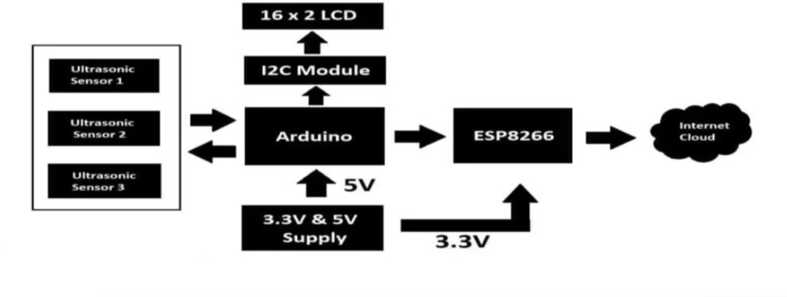

The circuit we are going to build will be based on the above architecture. An inexpensive Arduino board is going to be the brain of the project.

A 16 x 2 LCD is utilized for displaying the number of vacant spots locally (without internet). An I2C module is utilized for driving the LCD with just four wires so that GPIO pins can be saved for interfacing the sensors and other modules.

There are three ultrasonic sensors for detecting 3 cars / vehicles on the parking spot, we are using ultrasonic sensors instead of IR based sensors because if the parking lot is situated outdoors, infrared light from sunlight may interfere with IR sensors and may give incorrect detection of the vehicle, whereas ultrasonic sensor acts like a mini radar and environmental factors affecting its functionality is minimal.

An ESP8266 Wi-Fi module is used for internet connectivity which sends the parking lot’s data to a cloud server where general public can view the data in real time. A power supply module is utilized which provides 5V and 3.3V for Arduino, ultrasonic sensors and ESP8266 Wi-Fi Module.

The internet cloud service we are going to use is called “Thingspeak” where the parking lot’s data to be sent, stored and displayed in real time. This concludes the block diagram.

# Circuit Diagram for IoT Based Car Park Monitoring System:

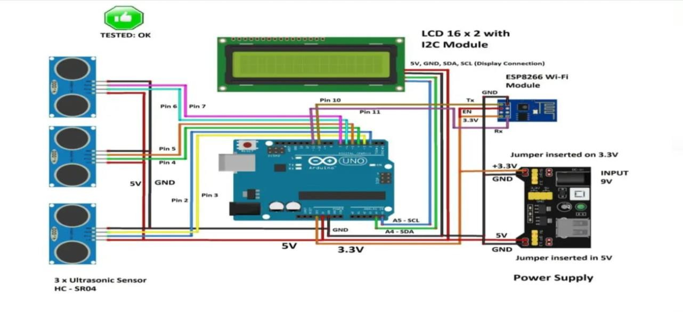

The above illustrated schematic consists of commonly available and easy to find modules. The brain of the project is an Arduino board and you can use any Arduino board with ATmega328p microcontroller.

## Power supply unit:

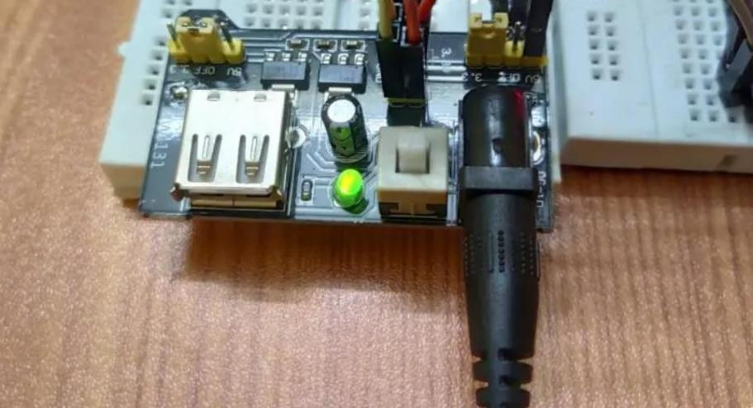

* A power supply module takes 9V to 12V DC from a wall adapter and converts in to 5V and 3.3V outputs, the 5V output from power supply module is directly connected to 5V pin of Arduino and GND of power supply is connected to GND of Arduino.
* Similarly 3.3V from the power supply unit is connected to 3.3V Vcc of ESP8266 (it operates strictly on 3.3V and 5V will kill the module), the ground of power supply is connected to ground of ESP8266.

## Generic ESP8266 Wi-Fi module:

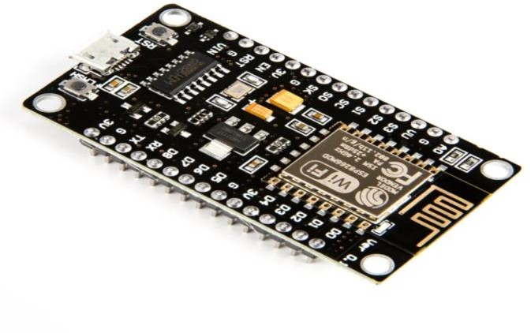

* Generic ESP8266
* This project utilizes a generic ESP8266 Wi-Fi module for internet connectivity. The ESP8266 is actually a miniature microcontroller board and just like Arduino the ESP8266 need a program code to perform its intended function.
* It uses UART protocol to communicate with Arduino board; the baud rate we are going to set for UART is 115200 bits per second.
* We can witness its pin diagram on back side of the ESP8266 module:

## Ultrasonic Sensor HC – SR04:

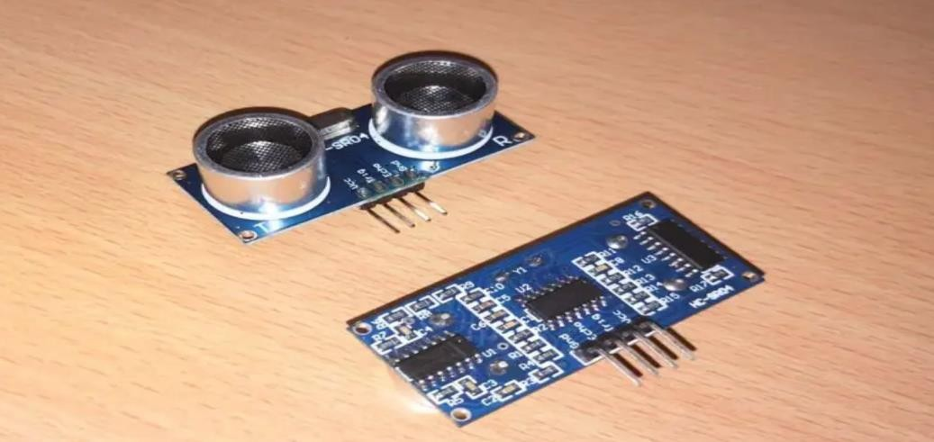

* Ultrasonic sensor
* The sensor we are going to use for detecting a parked vehicle on its parking spot is called HC
  + SR04 which is an ultrasonic sensor module.
* The ultrasonic sensor module generates ultrasonic sound at around 40 KHz, these sound waves are inaudible to human beings and propagate through air and if the ultrasonic sound wave hits an obstacle, it reflects back to sensor just like radars.
* If a car or any vehicle is parked, the ultrasonic sound waves hit the parked vehicle and the sensor module detects the reflection and thus existence of a vehicle on a parking spot is detected.
* The ultrasonic sensor module has four pins, Vcc, GND, trigger and echo. The Vcc is connected to 5V supply and GND is connected to GND of the supply. When we apply “HIGH” signal to trigger pin for 10 microseconds, the module generates ultrasonic sound from one of the transducers, when the sound wave hit back the other transducer, the echo pin gets “HIGH” and this signal is detected by Arduino.
* The time taken between generating and detecting the sound wave is calculated and thus a parked vehicle is detected.

## LCD display module 16 x 2:

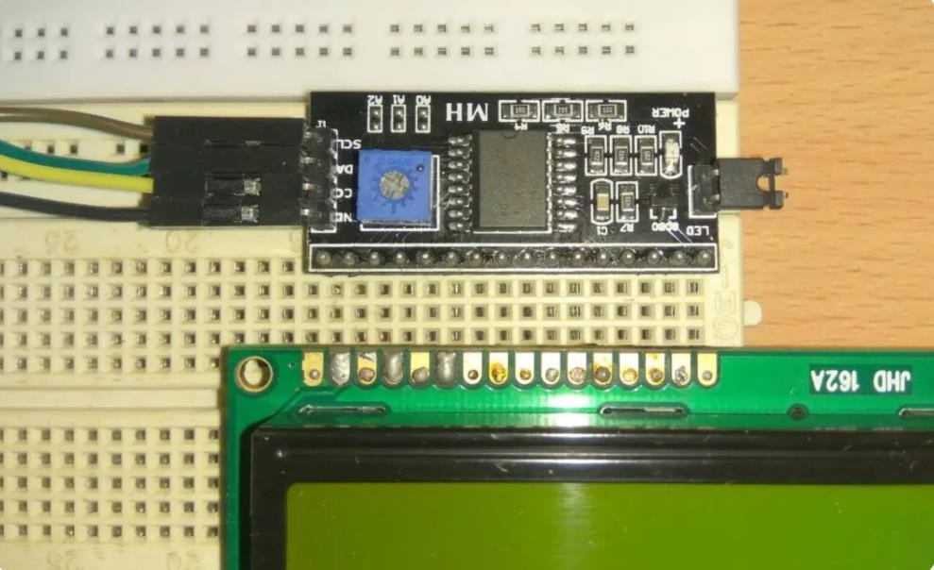

* I2C and LCD
* In this project we are using a 16 x 2 LCD display for displaying parking lot’s data locally without the need for internet. The LCD is driven by an I2C adapter module to reduce the number of wires to four; otherwise you need to connect up to 16 wires to Arduino just to drive the display. If the LCD occupies most of the I/O pins, then there won’t be any pins left for the sensors.
* The I2C module has 16 pins at the output and just four at the input: Vcc, GND, SDA and SCL. The SDA and SCL are I2C bus pins which are connected to A4 and A5 pins of Arduino respectively and it operates on 5V.
* You can control the contrast of the display by adjusting the trim pot on the I2C adapter module. This concludes about the circuit diagram.